**LANDIS-II WILDLIFE HABITAT SUITABILITY EXTENSION PERFORMANCE TESTS**

General set-up: For each suitability model I created 3 wildlife habitat suitability extension files, testing the 2 suitability parameters separately and then together. When testing parameters separately, suitability for the non-tested parameter was set to 1 for all potential values. Establishment shade tolerance was set to 0 to prevent tree reproduction during simulations, as tree reproduction makes it difficult to track age classes. Test files begin with DJB in test folder.

**Suitability Model:** AgeClass_ForestType

**File:** DJBageclass_foresttype_exampleAge

**Parameter tested:** AgeClass

**Test definitions:** Suitability = 0 (0-10 YO), 2 (11-30 YO), and 0 (> 30 YO). Initial communities set to 10 YO, and maps output at 10 year intervals.

**Test:** Suitability should be 0 for the first map (10 YO), then 100 for the next 2 maps (20 and 30 YO), then 0 for maps thereafter (>30 YO).

**Results:** Test success.

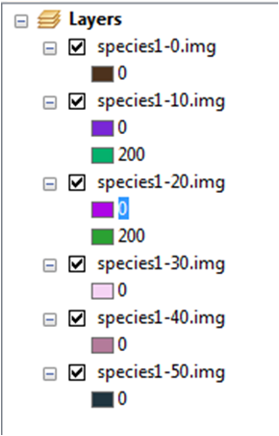

**Suitability Model:** AgeClass_ForestType

**File:** DJBageclass_foresttype_exampleFType

**Parameter tested:** ForestType

**Test definitions:** Suitability = 2 for MapleHardwood and 4 for Pine.

**Test:** Suitability should be 200 for MapleHardwood and 400 for Pine.

**Results:** Test success.

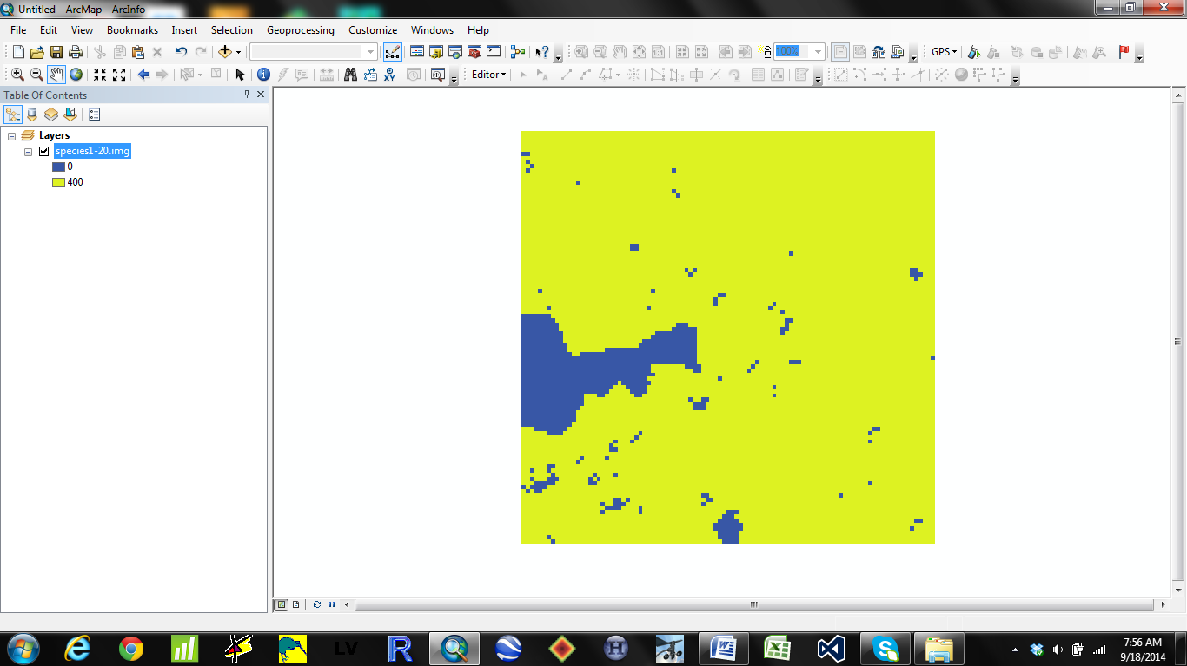

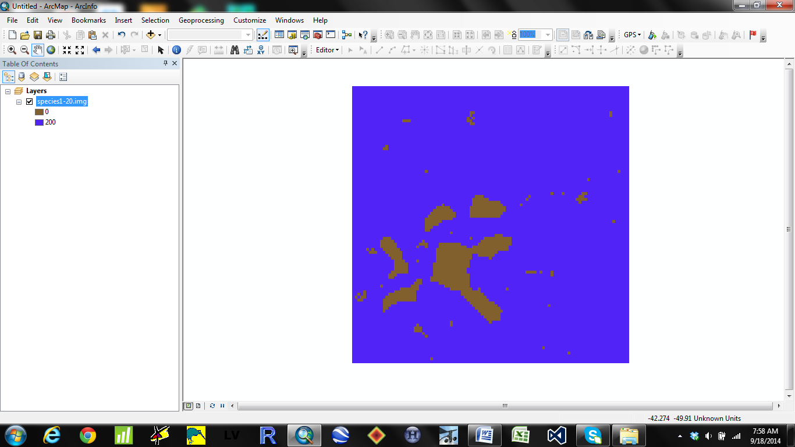

**Suitability Model:** AgeClass_TimeSinceFire

**File:** DJBageclass_tsf_exampleAge

**Parameter tested:** AgeClass

**Test definitions:** Suitability = 0 (0-10 YO), 2 (11-30 YO), and 0 (> 30 YO). Initial communities include jack pine and sugar maple, both set at 10 YO, and maps output at 10 year intervals.

**Test:** Suitability should be 0 for the first two maps (10 YO), 200 for maps 3 and 4 (20 and 30 YO), and 0 for maps thereafter. For this scenario, succession updates at 10 year intervals. Thus, at simulation year 10 the trees are 10 years old, at simulation year 20 the trees are 20 years old, etc…

**Results:** Test success.

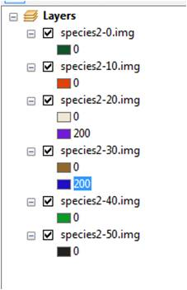

**Suitability Model:** AgeClass_TimeSinceFire

**File:** DJBageclass_tsf_exampleFireGeneral

**Parameter tested:** Suitability increase through time

**Test definitions:** Suitability = 0 for Severity Class 0 and 1 for Severity Class 1-5.

**Test:** Suitability should be 0 for non-burned areas and 100 for all burned areas.

**Results:** Test success. The first 2 maps show fire severity at 5 and 10 years, the 3rd map shows habitat suitability at year 10 of the simulation, which contains suitable habitat for the cells burned in the first 2 fire maps.

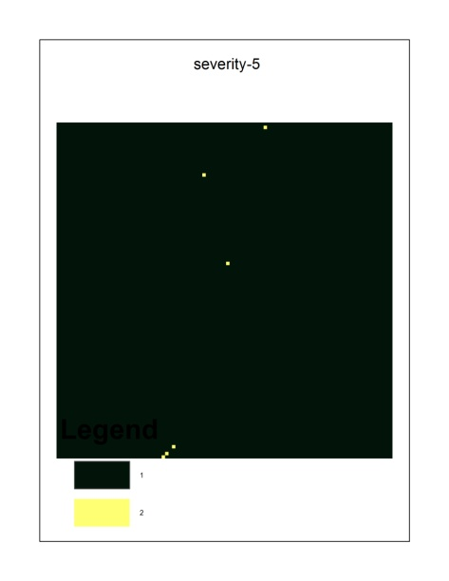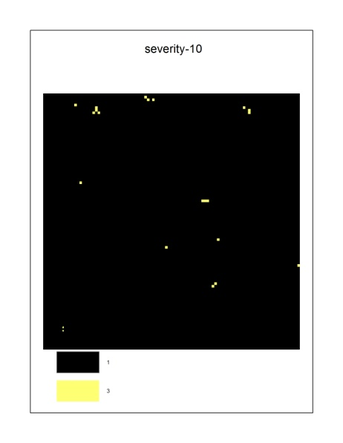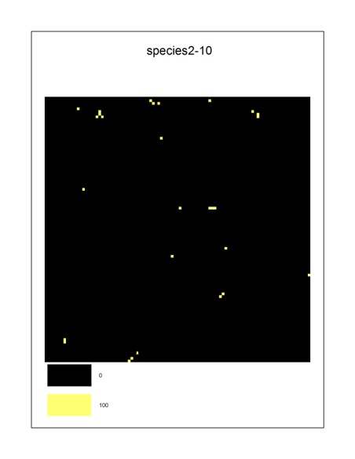

**Suitability Model:** AgeClass_TimeSinceFire

**File:** DJBageclass_tsf_exampleFire

**Parameter tested:** TimeSinceFire

**Test definitions:** Suitability = 1 for all age classes up to 10 years since fire. After 10 years suitability = 0.

**Test:** Suitability should be 100 within 10 years of fire, and 0 thereafter.

**Results:** Test success. Habitat suitability at time step 20 includes fire outputs at time steps 10, 15, and 20, but not time step 5. Maps: Top left (fire-5), top right (fire-10), middle left (fire-15), middle right (fire-20), bottom (habitat suitability at time step 20).

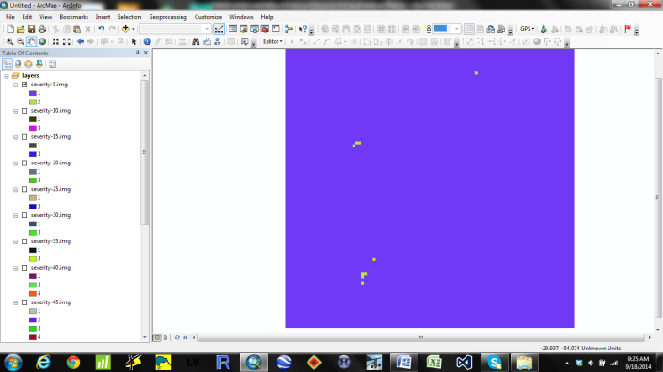 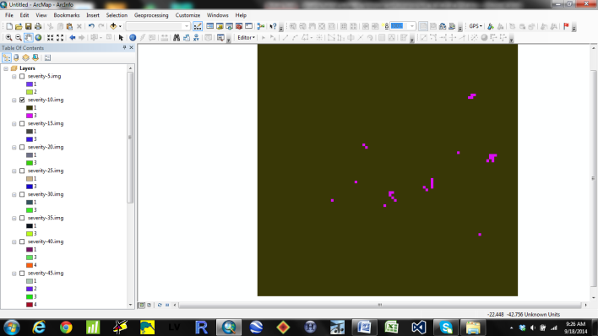 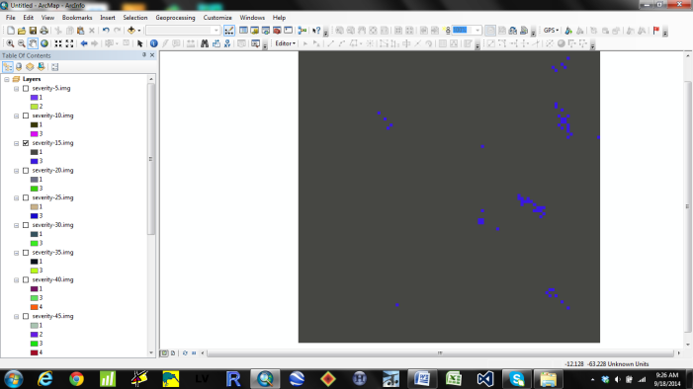 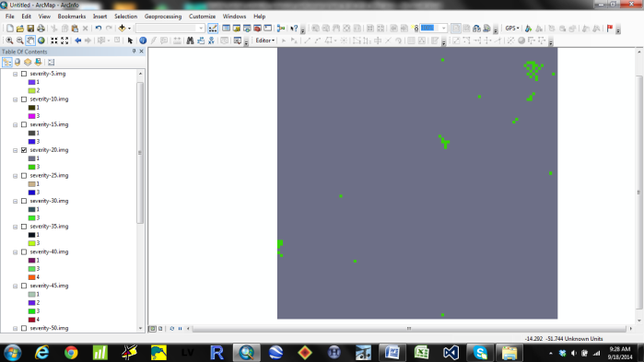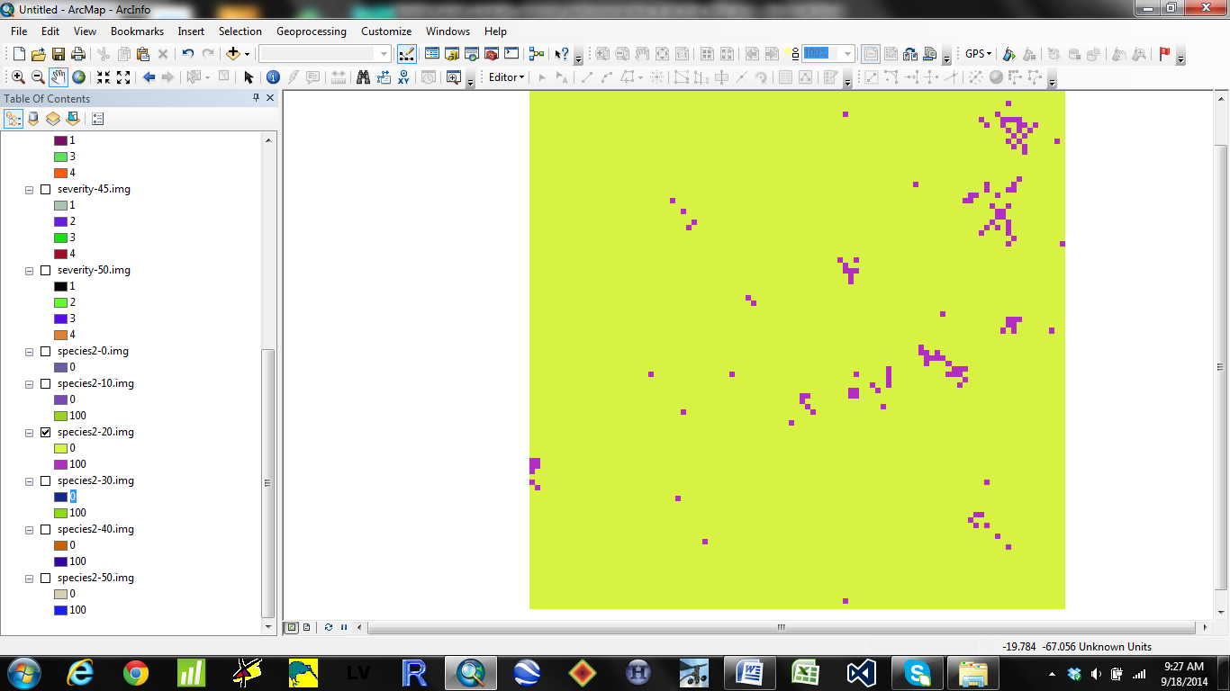

**Suitability Model:** AgeClass_TimeSinceFire

**File:** DJBageclass_tsf_exampleAgeFire

**Parameter tested:** Age andTimeSinceFire

**Test definitions:** Age suitability = 0 (0-10 YO), 1 (11-30 YO), and 0 (> 30 YO). Fire suitability = 0 for Severity Class 0 and 1 for Severity Classes 1-5. Suitability table:

<< MaxTimeSinceDist Maximum Age Values

<< ---------- -------------------

10 30 999

<< Suitability Values

<< -------------------

5 0 1 0

10 0 1 0

9999 0 0 0

**Test:** Only trees in time steps 20 and 30 are eligible for suitability. For time step 20, Suitability should only include areas burned in fire output maps 10, 15, and 20.

**Results:** Test success. Only correct age suitability shown below, but it was verified that TimeSinceFire suitability was also correct (i.e., areas burned in the severity-5 output were not suitable).

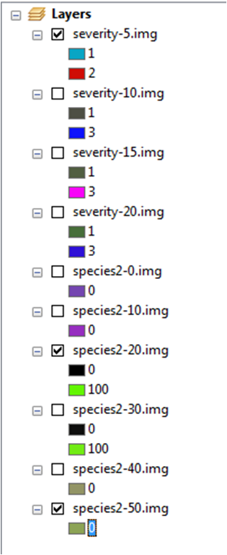

**Suitability Model:** AgeClass_TimeSinceHarvest

**File:** DJBageclass_tsh_exampleHarvestGeneral

**Parameter tested:** Suitability increase through time

**Test definitions:** All trees harvested at 20 YO. Suitability = 1 for all age classes and times since disturbance.

**Test:** Suitability in time 20 should include cumulative output from prescription output 10 and 20.

**Results:** Test success. Upper figures show harvested areas in year 0-10 and 11-20, bottom figures show suitable habitat in year 10 and 20.

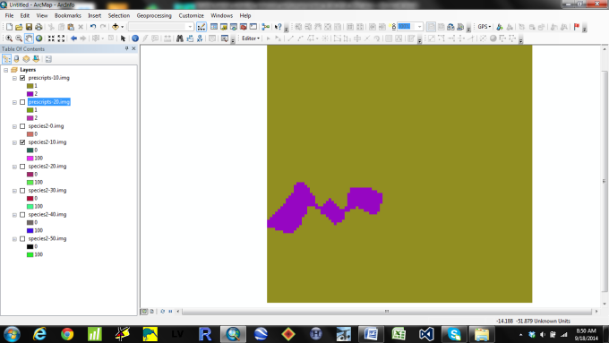 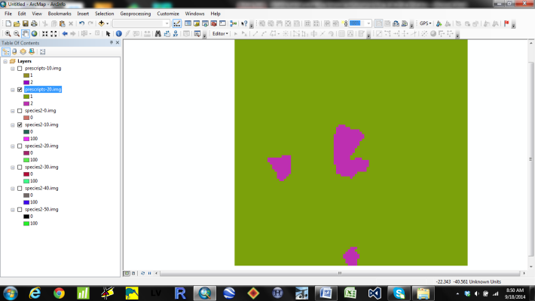

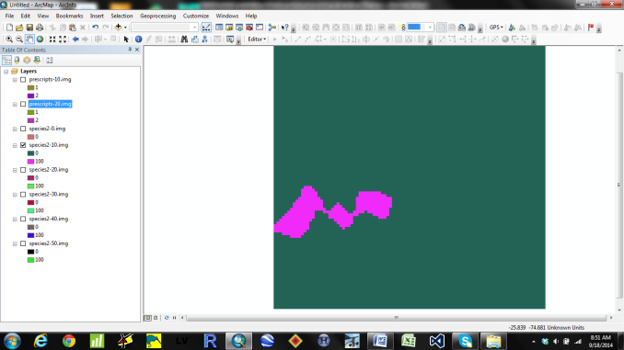 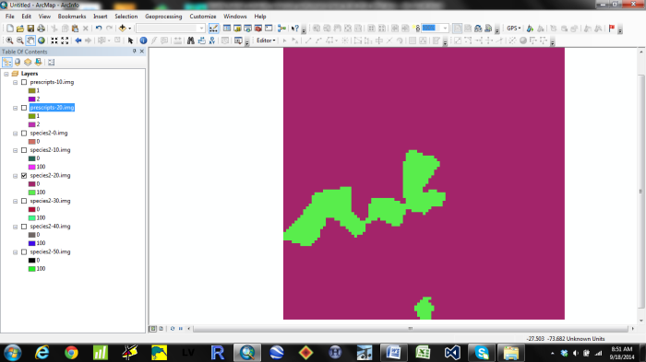

**Suitability Model:** AgeClass_TimeSinceHarvest

**File:** DJBageclass_tsh_exampleAge

**Parameter tested:** AgeClass

**Test definitions:** Suitability = 1 (0-10 YO), 2 (11-30 YO), and 0 (> 30 YO). Initial communities include jack pine and sugar maple, both set at 10 YO, and maps output at 10 year intervals.

**Test:** For areas harvested, suitability should be 100 for 0-10 YO trees, 200 for 20-30 YO trees, and 0 for trees >30 YO. Once harvested, the cells should remain suitable forever.

**Results:** Test success.

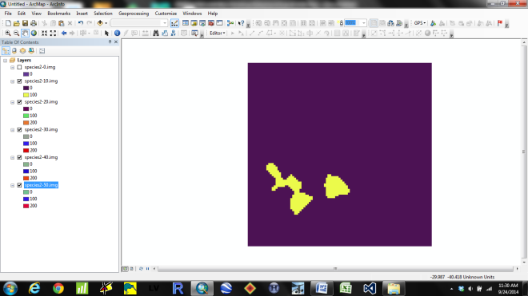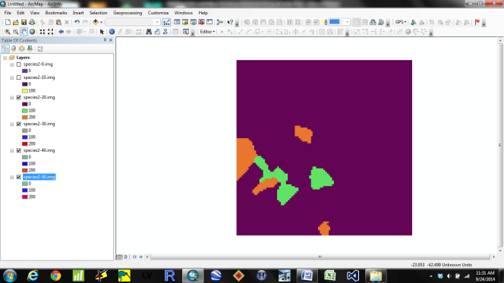

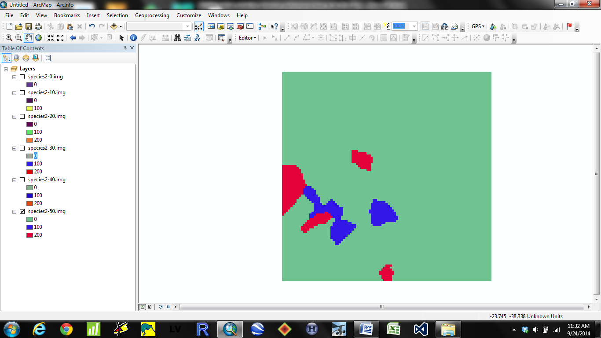

**Suitability Model:** AgeClass_TimeSinceHarvest

**File:** DJBageclass_tsh_exampleHarvest

**Parameter tested:** TimeSinceHarvest

**Test definitions:** All trees harvested at 20 YO. Suitability = 1 for all age classes up to 10 years since harvest. After 10 years suitability = 0.

**Test:** Suitability should be 100 within 10 years of harvest, and 0 thereafter.

**Results:** Test success. The first row shows harvest outputs at time steps 10 and 20. The remaining rows show habitat suitability at time steps 10, 20, 30, and 40.

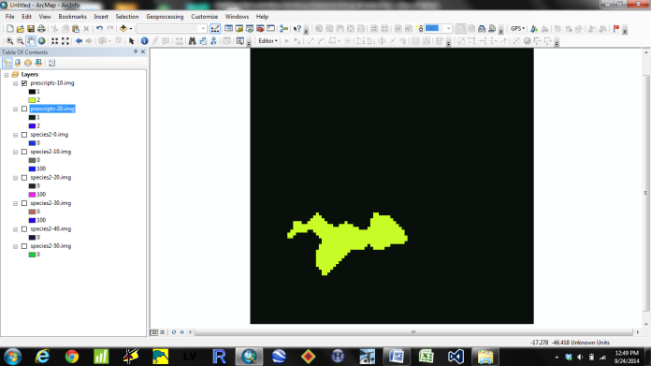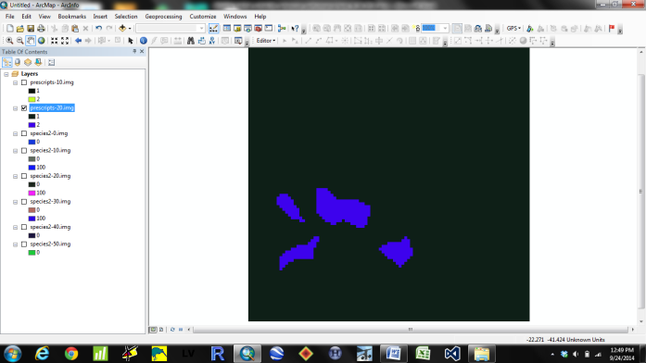

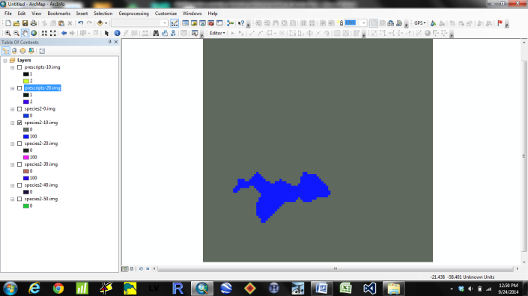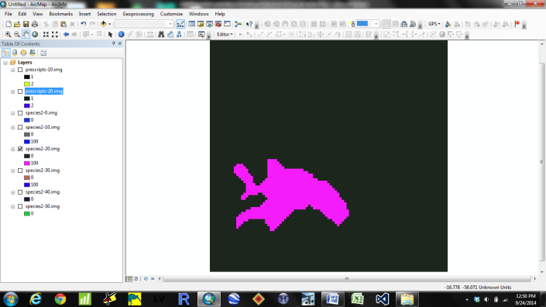

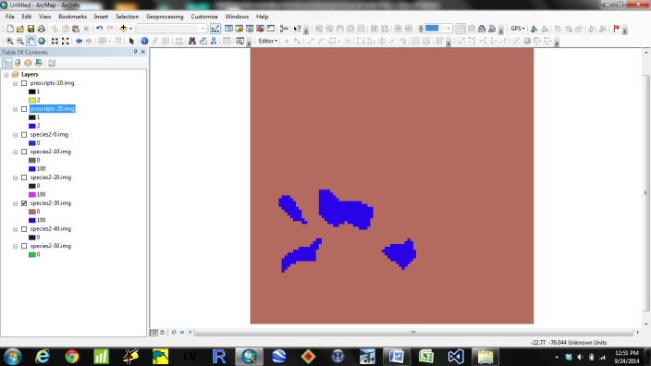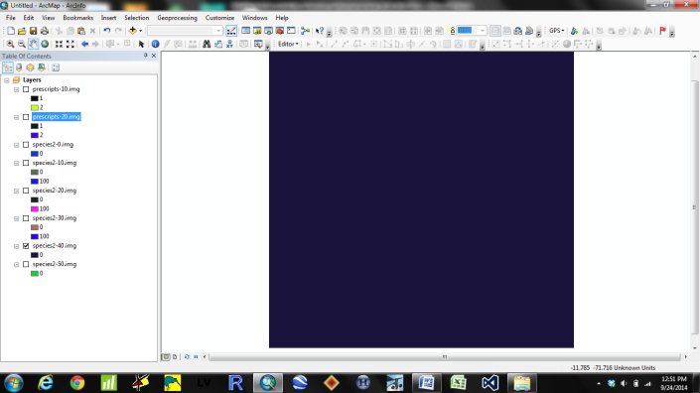

**Suitability Model:** AgeClass_TimeSinceHarvest

**File:** DJBageclass_tsh_exampleAgeHarvest

**Parameter tested:** Age and TimeSinceHarvest

**Test definitions:** Age suitability = 0 (0-10 YO), 2 (11-30 YO), and 0 (> 30 YO). Harvest suitability = 0 for non-harvested trees (0-19 YO), and 2 for harvested trees (20+ YO).

**Test:** Suitability should be 0 for the first map (10 YO), 400 for cells that were harvested when trees were 11-30 YO, and 0 for the remaining maps.

**Results:** Test success. Suitability was 0 for time step 10 (20 YO trees), but harvested cells became suitable at time step 20 (30 YO trees). Those cells became unsuitable in time step 40 when time since disturbance suitability became 0.

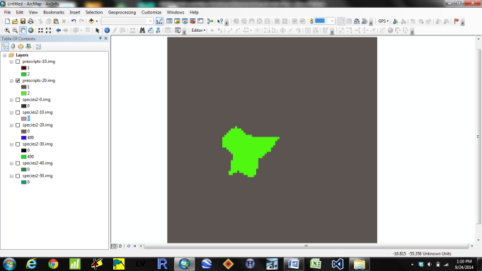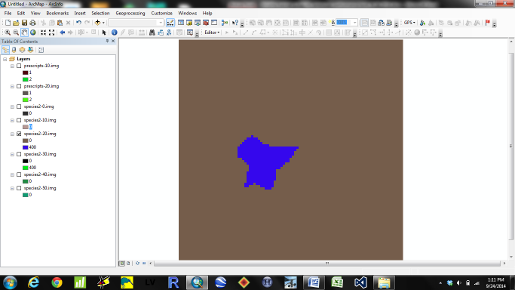

**Suitability Model:** ForestType_TimeSinceFire

**File:** DJBforesttype_tsf_exampleFType

**Parameter tested:** ForestType

**Test definitions:** Suitability = 2 for sugar maple and 4 for jack pine.

**Test:** Suitability should be 200 for sugar maple and 400 for jack pine.

**Results:** Test success.

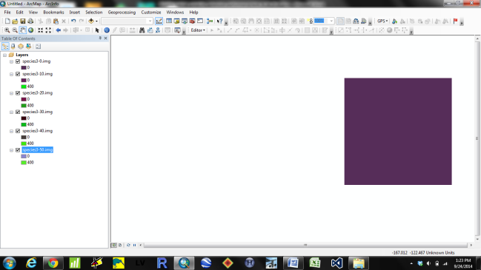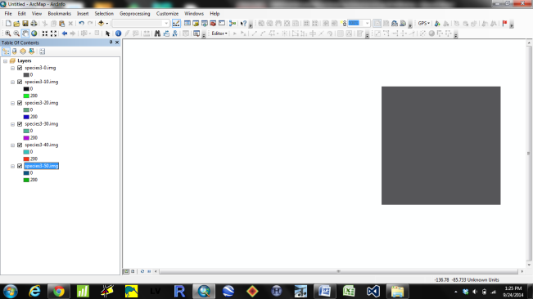

**Suitability Model:** ForestType_TimeSinceFire

**File:** DJBforesttype_tsf_exampleTimeSinceFireGeneral

**Parameter tested:** Suitability increase through time

**Test definitions:** Suitability = 0 for Severity Class 0 and 1 for Severity Class 1-5.

**Test:** Suitability should be 0 for non-burned areas and 100 for all burned areas.

**Results:** Test success. The first 2 maps show fire severity at 5 and 10 years, the 3rd map shows habitat suitability at year 10 of the simulation, which contains suitable habitat for the cells burned in the first 2 fire maps.

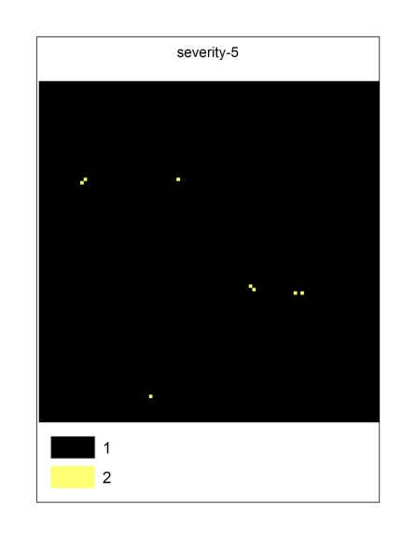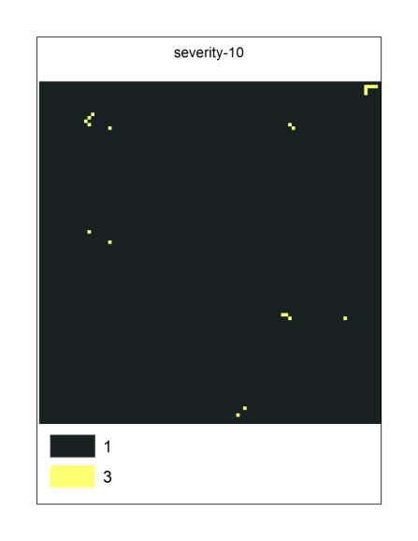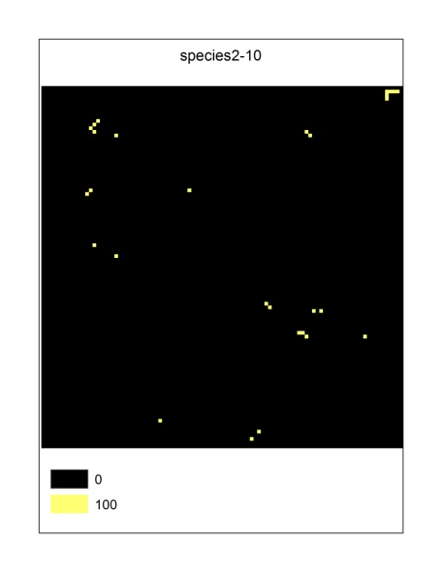

**Suitability Model:** ForestType_TimeSinceFire

**File:** DJBforesttype_tsf_exampleTimeSinceFire

**Parameter tested:** TimeSinceFire

**Test definitions:** Suitability = 1 for all age classes up to 10 years since fire. After 10 years suitability = 0.

**Test:** Suitability should be 100 within 10 years of fire, and 0 thereafter.

**Results:** Test success. At output time step 10 burned cells are suitable. At output time step 30 those cells are no longer suitable (but more recently burned cells are now suitable).

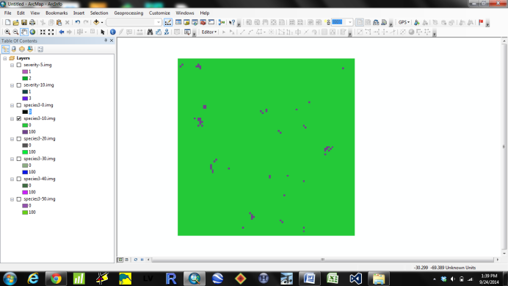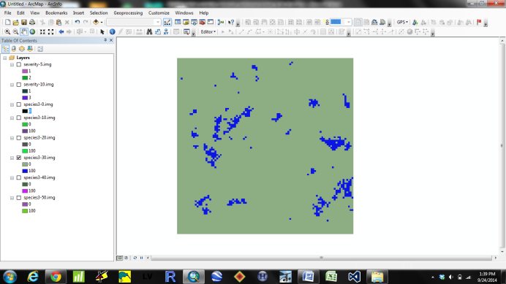

**Suitability Model:** ForestType_TimeSinceFire

**File:** DJBforesttype_tsf_exampleFTypeTimeSinceFire

**Parameter tested:** ForestType and TimeSinceFire

**Test definitions:** Suitability = 2 for sugar maple and 4 for jack pine. Suitability = 0 for Severity Class 0 and 1 for Severity Class 1-5. After 10 years, post-burn suitability = 0.

**Test:** Suitability should be 200 for MapleHardwood and 400 for pine sites burned, and stay suitable up to 10 years post-burn.

**Results:** Test success. The top-left figure shows suitable pine at time step 10, which includes fires burned up to the point. At time step 30 (top right figure) those cells are no longer suitable. The bottom figure just shows that MapleHardwood was classified at 200 (if it works for pine it should work for MapleHardwood).

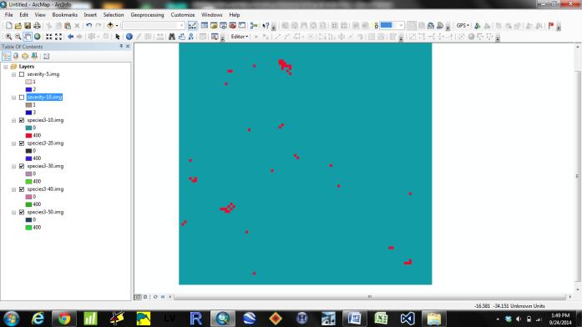 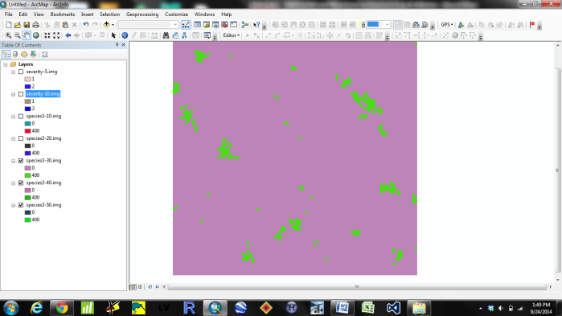

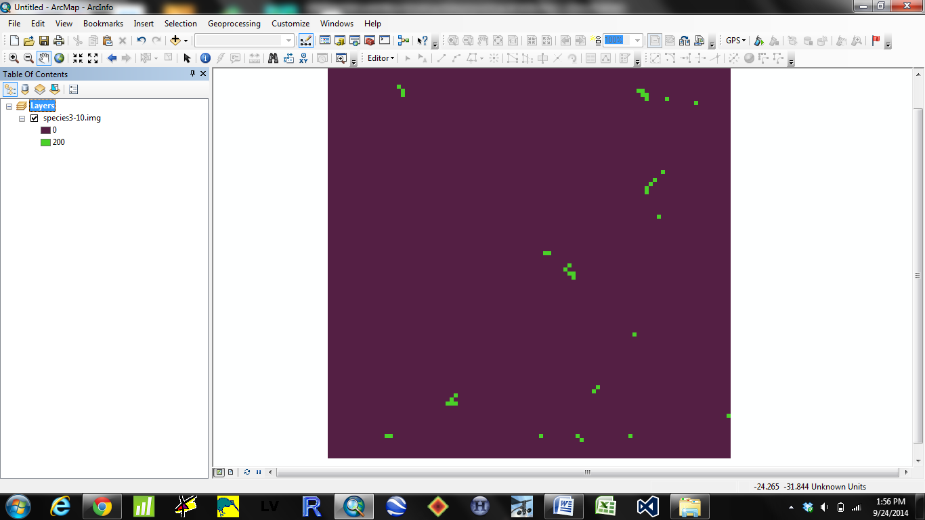

**Suitability Model:** ForestType_TimeSinceHarvest

**File:** DJBforesttype_tsh_exampleFType

**Parameter tested:** ForestType

**Test definitions:** Suitability = 2 for sugar maple and 4 for jack pine.

**Test:** Suitability should be 200 for sugar maple and 400 for jack pine.

**Results:** Test success.

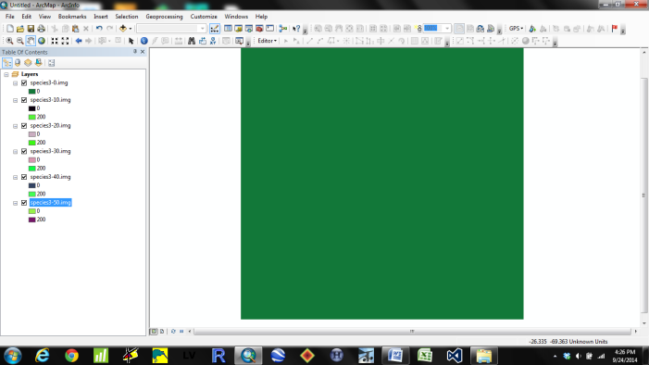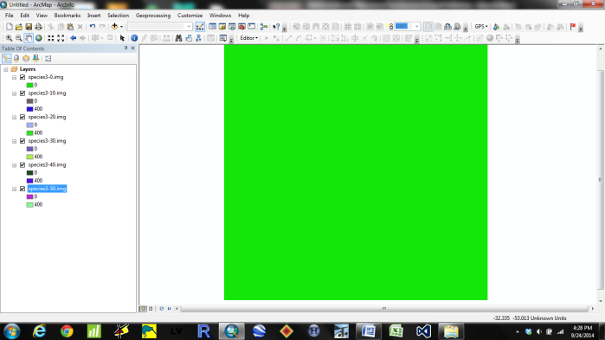

**Suitability Model:** ForestType_TimeSinceHarvest

**File:** DJBforesttype_tsh_exampleTimeSinceHarvestGeneral

**Parameter tested:** Suitability increase through time.

**Test definitions:** All trees harvested at 20 YO. Suitability = 0 for non-harvested trees (0-19 YO), and 2 for harvested trees (20+ YO).

**Test:** Suitability should be 0 for the first map (10 YO), and then 200 for maps thereafter (20+ YO).

**Results:** Test success. Suitability at time step 20 includes harvest output at time steps 10 and 20.

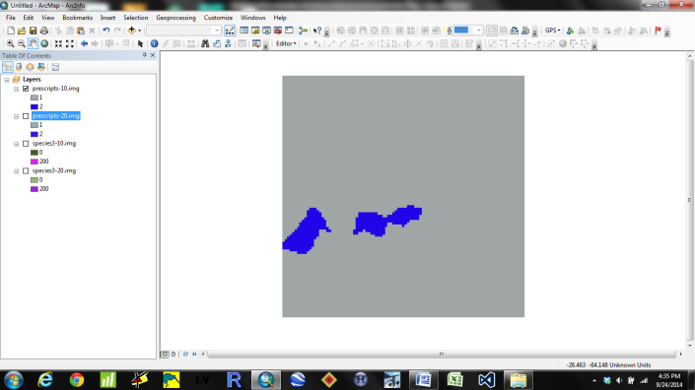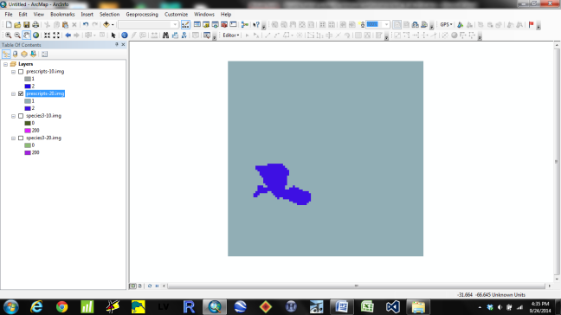

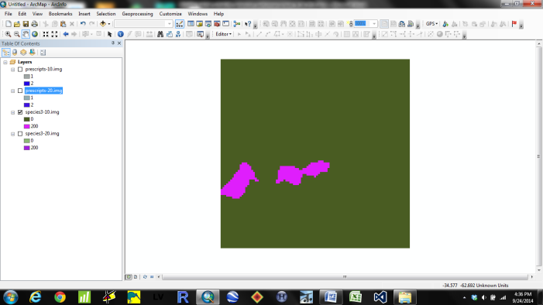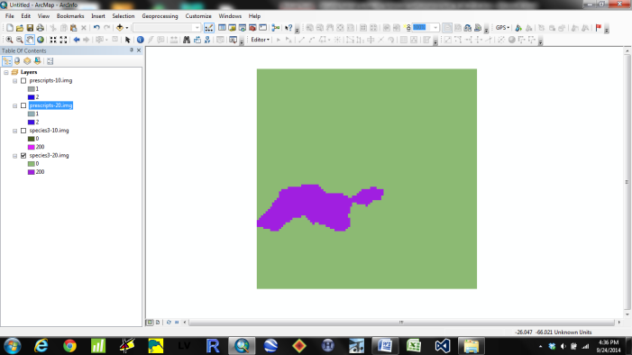

**Suitability Model:** ForestType_TimeSinceHarvest

**File:** DJBforesttype_tsh_exampleTimeSinceHarvest

**Parameter tested:** TimeSinceHarvest

**Test definitions:** All trees harvested at 20 YO. Suitability = 2 for all forest types up to 10 years since harvest. After 10 years suitability = 0.

**Test:** Suitability should be 200 within 10 years of harvest, and 0 thereafter.

**Results:** Test success. At output time step 10 all harvested cells are suitable. At output time step 30 those cells are no longer suitable (but cells harvested at time step 20 are still suitable).

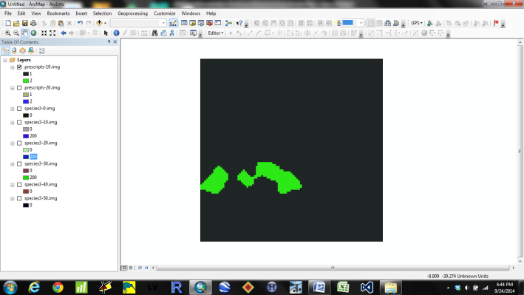 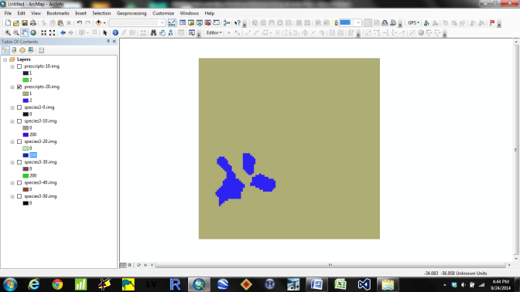

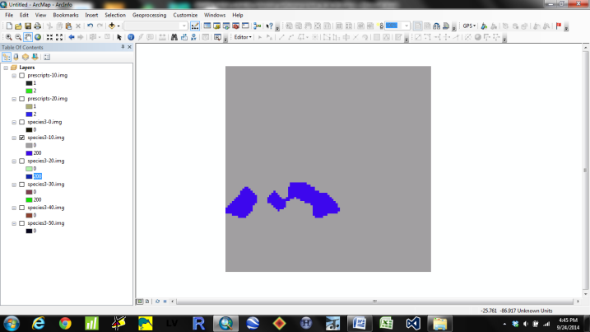 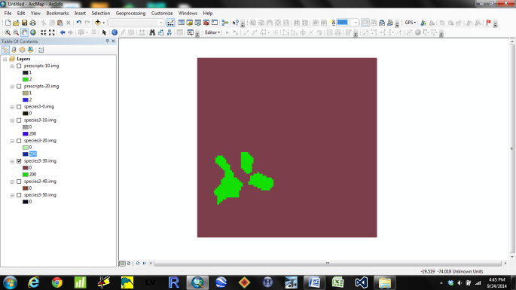

**Suitability Model:** ForestType_TimeSinceHarvest

**File:** DJBforesttype_tsh_exampleFTypeTimeSinceHarvest

**Parameter tested:** ForestType and TimeSinceHarvest

**Test definitions:** Suitability = 2 for sugar maple and 4 for jack pine. Suitability = 0 for Severity Class 0 and 1 for Severity Class 1-5. After 10 years, post-harvest suitability = 0.

**Test:** Suitability should be 200 for MapleHardwood and 400 for pine sites harvested, and stay suitable up to 10 years post-harvest.

**Results:** Test success. The top-left figure shows suitable pine at time step 10, which includes cells harvested up to the point. At time step 30 (top right figure) those cells are no longer suitable, but cells harvested at output time step 20 are suitable. The bottom figure just shows that MapleHardwood was classified at 200 (if it works for pine it should work for MapleHardwood).

